**Appendix A: Deriving Inverse Relationship**

Utilizing the figure below, I will derive the inverse relationship using the geometric approach.

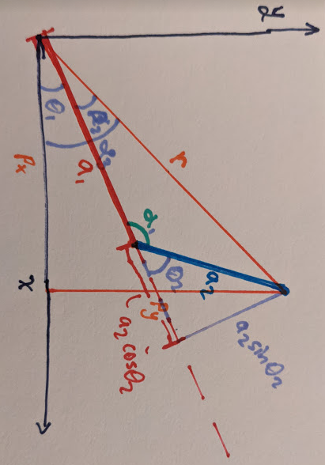

Noting a couple of relationships here:

$r^{2}=p_{x}^{2}+p_{y}^{2}=a_{1}^{2}+a_{2}^{2}-2a_{1}a_{2}c_{α_{1}}$

$-c_{α_{1}}=c_{2}$

Develop an expression for $c_{2}$:

$p_{x}^{2}+p_{y}^{2}=a_{1}^{2}+a_{2}^{2}+2a_{1}a_{2}c_{2}$

$c_{2}=\frac{p_{x}^{2}+p_{y}^{2}-a_{1}^{2}-a_{2}^{2}}{2a_{1}a_{2}}$

Utilizing some more defined geometry, $θ_{1}$ may be referenced in terms of these other relationships:

$α_{3}=α_{2}+θ_{1}$ $θ_{1}= α_{3}-α_{2}$

$α_{3}=\tan^{-1}\left(\frac{p_{y}}{p_{x}}\right)$

$α_{2}=\tan^{-1}\left(\frac{a_{2}s_{2}}{a_{1}+a_{2}c_{2}}\right)$

$θ_{1}=\tan^{-1}\left(\frac{p_{y}}{p_{x}}\right)- \tan^{-1}\left(\frac{a_{2}s_{2}}{a_{1}+a_{2}c_{2}}\right)$

This leaves us with the ability to uses either the elbow up or down orientations, which when re-deriving above gives us the final relationships of:

$θ_{2}=σ\cos^{-1}\left(\frac{p_{x}^{2}+p_{y}^{2}-a_{1}^{2}-a_{2}^{2}}{2a_{1}a_{2}}\right)$

$$θ_{1}=\tan^{-1}\left(\frac{p_{y}}{p_{x}}\right)-σ\tan^{-1}\left(\frac{a_{2}s_{2}}{a_{1}+a_{2}c_{2}}\right)$$